

Software Engineering Department  
ORT Braude College

Capstone Project Phase A – 61998

**ElderEase- An application that connects between elder people and volunteers**

**24-1-D-23**

**Abstract** 4

**1. Introduction** 5

**2. Related Work** 6

*2.1 The importance of helping the elderly by volunteers according to articles:* 6

*2.2 Qualities and requirements expected of volunteers:* 7

*2.3 risks involved in the assistance of volunteers to adults through an application:* 8

*2.4 existing apps exist that offer assistance to the elderly in daily tasks:* 9

**3. Background** 19

*3.1 Project Continuation:* 19

*3.2 Yedidim Application:* 19

*3.3 Uber Application:* 19

*3.4 The combination between**Yedidim and Uber* 20

**4. Expected Achievements** 22

*4.1 Outcomes*: 22

*4.2 Unique Features*: 22

*4.3 Criteria for Success* 23

**5. The Process** 25

*5.1 Research – The needs of older individuals* 25

*5.2 Methodology and Development Process* 26

*5.3 Development Process* 27

**6. Product** 28

*6.1 Our solution* 28

*6.2 Requirements* 29

*6.3 System functionality* 30

*6.4 Technology choices:* 32

*6.4.1* *Back-end NODEJS* 32

*6.4.2 Back-end MONGODB* 33

*6.4.3 Front-end REACT-NATIVE* 34

*6.4.4 Visual studio code framework* 35

*6.5 Project structure* 36

*6.6* *Algorithms*: 37

*6.7* *Diagrams*: 38

*6.7.1 use case diagram* 38

*6.7.2* *Activity diagram* 39

*6.8 Tests* 40

*6.8.1 Login Tests:* 40

*6.8.2 Volunteer & Pre-Volunteer Tests* 40

*6.8.3 elderly Tests* 41

*6.8.4 Manager Tests* 42

**7. GUI** 43

*7.1 Elder's screens:* 43

*7.2 Manager's Screens:* 44

*7.3 Volunteer's Screens:* 45

**8. References** 46

# **Abstract**

Older individuals, often referred to as seniors or elderly, constitute a diverse demographic with unique needs and challenges. As people age, they may encounter physical, cognitive, and emotional changes that can impact their ability to perform daily activities independently. Mobility issues, chronic health conditions, memory loss, and social isolation are common challenges faced by many older adults. These factors can make tasks such as grocery shopping, meal preparation, medication management, and household chores more challenging. Additionally, the need for companionship and social interaction becomes increasingly vital to combat feelings of loneliness and maintain mental well-being. Recognizing and addressing these needs is crucial to ensuring a high quality of life for the elderly, and volunteer assistance can play a significant role in providing the support and companionship necessary for them to age with dignity and fulfillment. Up until now, there hasn't been a convenient solution for the problem described above. We propose the development of a mobile application that serves as a bridge between older adults and volunteers eager to assist them in their daily routines. This application leverages modern technology to facilitate meaningful connections and support networks. Users, both older adults, and volunteers, can create personalized profiles with information on interests, skills, and availability. The application employs a sophisticated matching algorithm to pair volunteers with older individuals based mainly on geographic proximity. Volunteers can offer assistance with daily routines such as grocery shopping, meal preparation, medication reminders, or companionship through planned activities. Feedback and ratings mechanisms are implemented to ensure accountability and maintain a high standard of service, with safety features such as background checks and emergency contact integration. The application also includes features for event planning and progress tracking, promoting community building and reducing social isolation. By providing a user-friendly and secure platform, this application aims to empower volunteers, make a positive impact on the lives of older individuals, and contribute to the creation of a more interconnected and supportive community.

# **1. Introduction**

In the realm of aging, older individuals often find themselves grappling with a myriad of challenges that significantly impact their daily routines. Physical limitations, cognitive changes, and the complexities of managing healthcare needs can collectively pose formidable obstacles, hindering their ability to navigate even the simplest tasks.

Delving deeper into the daily struggles faced by the elderly, these challenges extend beyond the physical domain. Many older individuals experience social isolation, exacerbated by mobility issues or the absence of a robust support system. The cumulative effect of these difficulties often leads to a diminished quality of life and heightened healthcare costs. Moreover, the lack of accessible and comprehensive support exacerbates the situation, leaving many older individuals underserved and their needs unmet. As our global population continues to age, the demand for tailored solutions to address these challenges becomes increasingly urgent.

Due to the circumstances described above, we propose an innovative solution in the form of an application. This digital platform aims to bridge the gap between older individuals and compassionate volunteers, offering a lifeline of support. Through the application, older users can articulate their daily routines, challenges, and preferences, providing a comprehensive overview of their unique needs. The application's algorithm then leverages this information to seamlessly match them with qualified volunteers who possess the skills and availability to assist. Be it grocery shopping, transportation, or companionship, the application cultivates symbiotic relationships that transcend mere assistance. Integrating features such as volunteer background checks, ratings, and reviews ensures a secure environment, fostering trust between the older individuals seeking support and the volunteers eager to make a positive impact. By harnessing technology to facilitate these connections, the application aims to enhance the overall well-being of older individuals, foster a sense of community, and address the challenges of aging in a more interconnected and supportive society.

# **2. Related Work**

## *2.1 The importance of helping the elderly by volunteers according to articles:*

Volunteer assistance programs for elderly individuals offer a range of benefits that contribute to their overall well-being and quality of the elderly life. Research has consistently shown that these volunteers have a positive impact on both the physical and psychological health of elderly individuals.

One significant benefit of helping elderly by volunteering is the promotion of social interaction and companionship among elderly. Loneliness and social isolation are prevalent issues among the aging population, which can have detrimental effects on mental and physical health. A study by Holt-Lunstad, Smith, and Layton (2010) found that there is a connection between social relationships in older people and the risk of mortality and emphasizes the importance of social relationships for health and general well-being in older people.

Similarly, Hawkley and Cacioppo (2010) emphasized the importance of social connections against the negative effects of stress and promoting overall health and longevity. In addition a study by Cohen-Mansfield, Dakheel-Ali, and Jensen (2015) found that regular social interactions, such as those facilitated by volunteer visits, associated with reduced loneliness and improved well-being among elderly individuals.

Moreover, volunteer assistance can help elderly individuals maintain their independence and autonomy by providing support with daily tasks and activities. Volunteers can assist with household chores, grocery shopping, transportation to medical appointments, and other essential tasks that may become challenging for elderly individuals as they age. Research by Buffel and Handler (2014) demonstrated that volunteer-based support programs contribute to the ability of elderly individuals to age in the place they live by providing practical assistance and enhancing their sense of control and autonomy. Additionally, studies by Morrow-Howell and colleagues (2020) have emphasized the importance of integrating volunteer services with existing community resources to maximize support for elderly individuals and promote aging in place they live.

In addition to practical assistance, volunteers often serve as advocates and allies for elderly individuals, helping them navigate complex healthcare systems and access needed resources and services. The personal relationships that develop between volunteers and elderly recipients can foster trust and empower elderly to seek help when needed. A study by Warburton and colleagues (2013) highlighted the role of volunteers in supporting elderly individuals to engage with healthcare services effectively, leading to improved health outcomes and satisfaction with care. Similarly, research by Gorges and colleagues (2015) has shown that volunteer play a crucial role in ensuring that elderly individuals receive appropriate medical care and support, particularly in the context of end-of-life decision-making.

Furthermore, volunteer assistance programs have been shown to improve the mental and emotional well-being of elderly individuals. Interactions with volunteers can boost self-esteem, provide a sense of purpose, and enhance feelings of belonging and connectedness. A longitudinal study by Li and colleagues (2019) found that participation in volunteer activities was associated with reduced depressive symptoms and improved life satisfaction among elderly participants. Similarly, research by Musick and Wilson (2008) has highlighted the reciprocal benefits of volunteering, showing that volunteers experience greater life satisfaction and lower levels of depression and anxiety.

Overall, volunteer assistance programs offer a holistic approach to supporting the needs of elderly individuals, addressing not only practical challenges but also emotional and social needs. By fostering meaningful connections and providing essential support, these programs contribute to the overall health and well-being of elderly individuals, promoting a higher quality also in life in later years.

## *2.2 Qualities and requirements expected of volunteers:*

The attributes that are crucial for providing effective and compassionate assistance to older adults, enhancing their quality of life and independence are-

* **Reliable**: Showing up as promised and being dependable.
* **Empathetic**: Understanding their feelings and needs.
* **Patient**: Taking the time to listen and assist without rushing.
* **Respectful**: Treating them with dignity and consideration.
* **Communicative**: Clear and effective communication skills.
* **Adaptable**: Willing to adjust assistance as their needs change.
* **Knowledgeable**: Having basic knowledge of care needs and when to seek additional help.

## *2.3 risks involved in the assistance of volunteers to adults through an application:*

Risks involved in the assistance of volunteers to adults through an application:

1**. Privacy and Data Security Risks:** There may be concerns regarding the privacy and security of personal information shared on the app, including sensitive health or financial data.  
2. **Reliability and Trustworthiness of Volunteers**: There is a risk that volunteers may not be reliable or trustworthy, leading to potential issues such as missed appointments, inadequate assistance, or even exploitation or abuse.  
3. **Digital Accessibility Barriers**: Some older adults may face challenges in using the app due to digital literacy issues, physical impairments, or lack of access to technology, potentially excluding them from receiving assistance.  
4. **Miscommunication or Misunderstanding**: There is a risk of miscommunication or misunderstanding between volunteers and adults, particularly in cases where language barriers, cultural differences, or cognitive impairments exist.  
5. **Dependence on Technology**: Older adults may become overly reliant on the app for assistance, potentially reducing their reliance on traditional support networks or diminishing their ability to seek help offline.  
These risks underscore the importance of implementing safeguards and best practices to ensure the safety, privacy, and well-being of both volunteers and adults receiving assistance through the app.

6. **Unprofessional Behavior**: Volunteers may engage in unprofessional behavior, such as being disrespectful, unreliable, or unethical in their interactions with adults, which can undermine the quality of assistance and erode trust.

**7. Lack of Supervision and Oversight**: Without proper supervision and oversight, volunteers may operate independently and without accountability, leading to potential issues such as inadequate support, neglect of duties, or failure to adhere to organizational policies and procedures.  
**8. Risk of Burnout:** Volunteers may experience burnout or compassion fatigue due to the emotional demands and stress associated with assisting adults in need, particularly in cases of chronic illness, disability, or complex care needs.

## *2.4 existing apps exist that offer assistance to the elderly in daily tasks:*

**1.** **TaskRabbit:**

Function Details: TaskRabbit is essentially an online marketplace where individuals ("Clients") can post tasks they need help with and browse profiles of independent workers ("Taskers") who offer their services. These tasks can range from simple errands like grocery shopping to more complex projects like furniture assembly or handyman services.

How it Works: Clients post their task details, including location, timeframe, and budget. Taskers then submit bids on the project, outlining their qualifications and proposed price. Clients can review and choose the Taker that best suits their needs. Both parties communicate and schedule the task through the platform. After completion, the client pays the Tasker through the app, and TaskRabbit collects a service fee.

Examples of Tasks:

Cleaning (deep cleaning, regular cleaning, carpet cleaning)

Handyman services (furniture assembly, mounting TV, plumbing repairs)

Errands (grocery shopping, dry cleaning pick-up, package delivery)

Moving assistance (packing, loading/unloading, furniture moving)

Delivery (furniture delivery, appliance installation)

Pros and Cons:

Pros:

1. Convenience: Helps with tasks that can be difficult or time-consuming, like furniture assembly or yard work.  
2. Variety of services: Offers a wide range of assistance, from cleaning to errands to handyman services.  
3. Pre-vetted Taskers: Background checks and reviews help you choose reliable and experienced individuals.

Cons:

1. Costs involved for each task can add up quickly.  
2. Quality and reliability of Taskers can vary.  
3. Requires upfront planning and scheduling.  
4. potential for scams or unreliable Taskers.  
5. Safety concerns: Inviting strangers into their homes might be a concern for some older adults.  
6. Technology barrier: Using the app and navigating the platform might be challenging for some older adults not familiar with technology.

Usage:

• Over 3 million users have completed tasks on TaskRabbit.

• Available in over 50 major cities in the US, Canada, UK, Australia, and Germany.

Images of TaskRabbit application:   
1. Choose the topic you want to ask for help on -

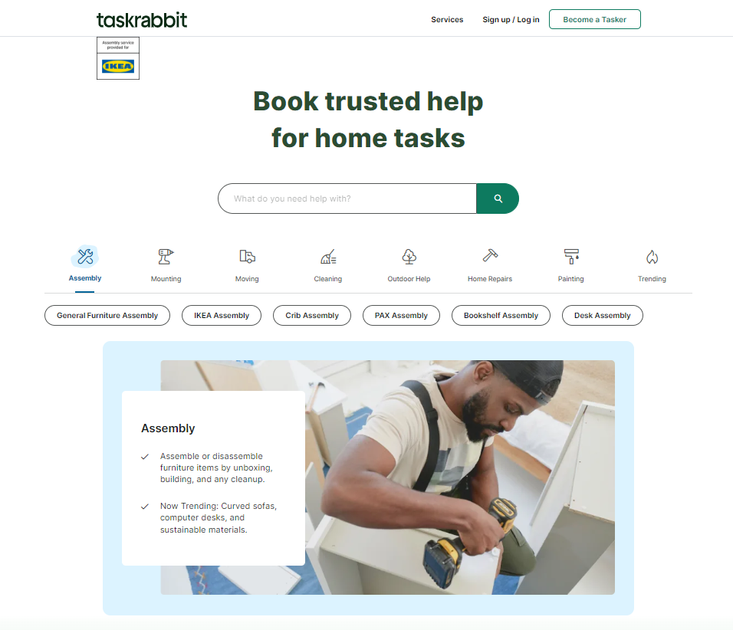

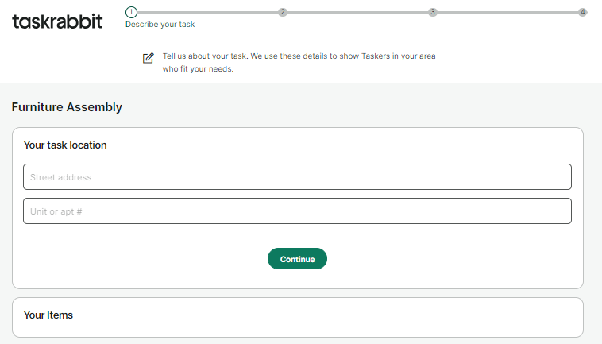2. Enter details about your task

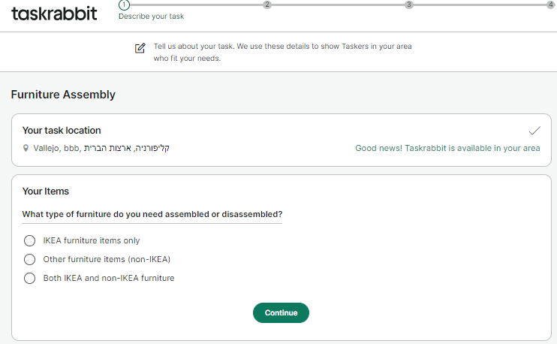

3. You will get a variety of people who can help you, you can read opinions about them, see what price they ask for an hour of work, choose a price range you are willing to pay, etc.

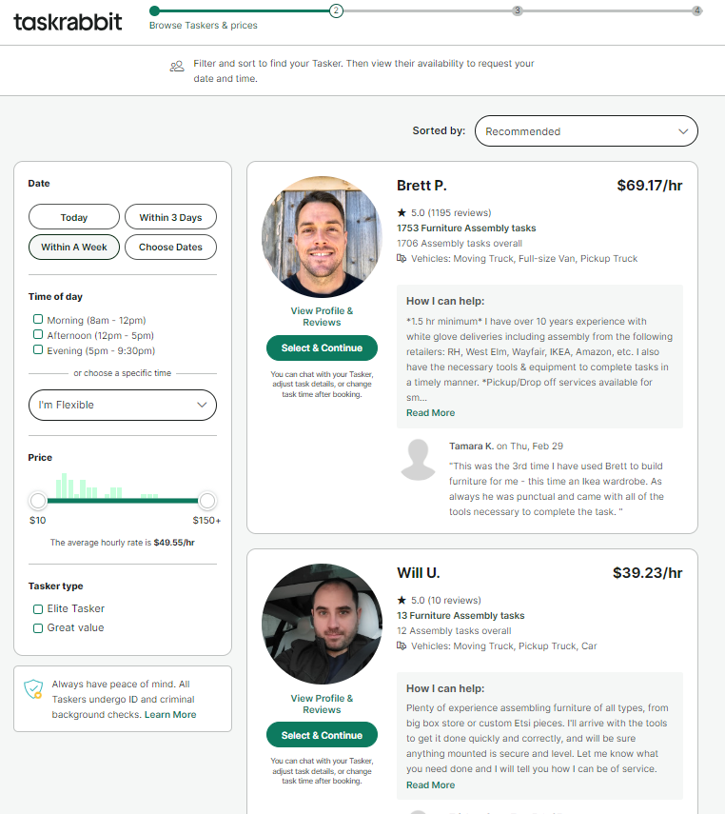

4. After choosing the right person for you, you will need to set a date to carry out the task where the dates shown are the dates that are convenient for him.Then contact him

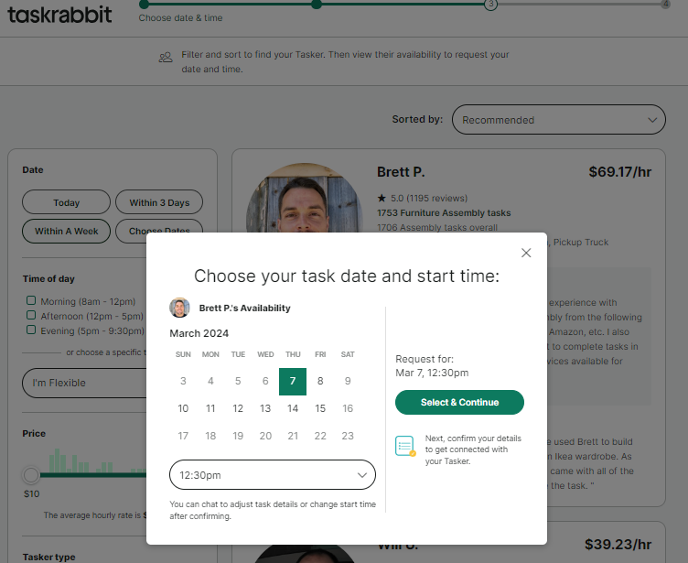

**2. Nextdoor:**

Function Details: Nextdoor connects neighbors in a specific geographic area to foster community and offer mutual support. Nextdoor acts as a private social network specifically for your neighborhood. Verified residents can join their local community page to connect with neighbors, share information, and offer or request assistance.

Features:

Posts: Users can create posts seeking recommendations for local services, reporting suspicious activity, lost or found pets, or organizing neighborhood events.

Groups: Join pre-existing groups or create your own to connect with neighbors with shared interests, such as gardening or book clubs.

Direct messaging: Chat privately with individual neighbors for specific assistance or communication.

Safety features: Includes features like verified profiles and moderation to foster a safe and secure environment.

Examples of Assistance:

Finding a plumber or babysitter: Ask for recommendations from trusted neighbors who have used these services.

Borrowing a tool or ladder: Avoid purchasing tools you'll only use once by borrowing from a neighbor.

Finding a lost pet: Share information and coordinate search efforts with the local community.

Organizing a block party: Connect with neighbors and plan events to build community spirit.

Pros and Cons:

Pros:

1. Limited Scope: Only available in specific neighborhoods and relies on active participation from residents.  
2. Potential for Misuse: The platform could be misused by individuals with malicious intent.  
3. May not be suitable for all neighborhoods or demographics.  
4. Technology barrier: Using the app and navigating the online platform might be challenging for older adults unfamiliar with technology.  
  
  
Cons:  
1. Sense of community: Provides a platform to connect with neighbors and combat social isolation, which can be common among older adults.  
2. Local information: Offers a valuable resource for finding recommendations, staying informed about community events, and seeking help with local issues.  
3. Potential for assistance: Neighbors can offer support with tasks like borrowing tools or receiving help after a minor fall.  
  
Usage:  
• Over 255 million users have signed up for Nextdoor.   
• Available in over 285,000 neighborhoods worldwide, primarily in the US, UK, Australia, and the Netherlands.

Images of Nextdoor application:

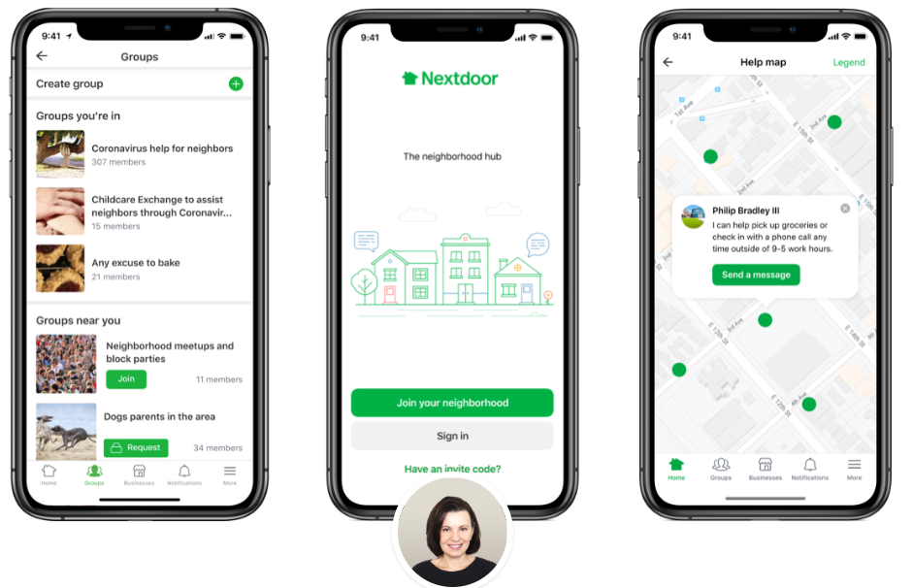

**3. 7 Cups of Tea:**

Function Details: 7 Cups of Tea Offers emotional support and active listening through online chat with trained volunteer listeners. 7 Cups of Tea provides emotional support through online chat with volunteer listeners. These listeners are trained in active listening and basic crisis intervention skills, offering a safe space to vent, share experiences, and receive non-judgmental support.

Process: Users can create an account and connect anonymously with a volunteer listener who is available. Chat sessions typically last 30-45 minutes, and users can choose to end a session and connect with another listener or come back later.

Additional Resources: The platform also offers self-help resources, articles on mental health topics, and information about finding professional help.

Pros and Cons:

Pros:

1. Limited ability to provide ongoing support due to the volunteer nature of the service.  
2. Volunteers are not mental health professionals and cannot provide diagnoses or treatment.  
3. Potential for technical difficulties or disruptions during chat sessions.  
4. Wait Times: Due to volunteer availability, there might be delays in connecting with a listener.  
5. Technology Barrier: Using the app or website might be challenging for older adults unfamiliar with technology.  
  
Cons:  
1. Provides free, anonymous support and a safe space to talk about emotional challenges. Can be a helpful resource for people who are struggling with loneliness, anxiety, or other mental health concerns.  
2. Free, anonymous support and a safe space to talk.  
3. Crisis Support: If needed, the platform can connect you with resources for immediate help.  
4. Accessibility: Available worldwide and accessible from any device with internet.

Usage:  
• Users: Over 50 million people have accessed support on 7 Cups of Tea according to their website. However, this number doesn't necessarily represent active users.  
• Availability: The platform claims to be available worldwide.

Images of 7 Cups of Tea application:

1. Home page-  
there is an option to chat with a listener

2. Enter Topics you want to talk about:

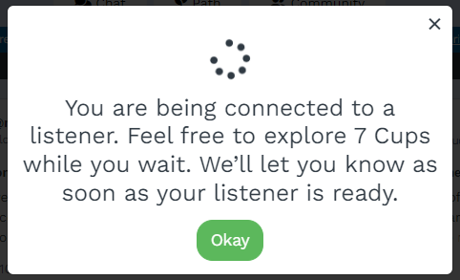3. Wait to your listener:

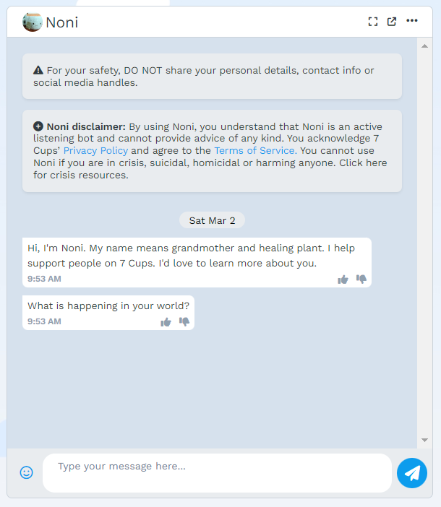4. The chat with listener start:

In Summary, in Israel applications such as 7 Cups of Tea, Nextdoor, and TaskRabbit have not gained widespread adoption, particularly among older demographics who may not be as tech-savvy or inclined to use such platforms. The user interfaces and functionalities of these apps may not be easily accessible or intuitive for older individuals, further limiting their usage among this population.

Furthermore, apps like Nextdoor and TaskRabbit, which offer physical assistance such as local services and errand running, are not readily available in Israel. While these types of services can greatly benefit older adults by providing practical support in their daily lives, their absence from the Israeli market further compounds the challenges faced by this demographic.

While these apps offer valuable services, they often come with associated costs, underscoring the reality that achieving one's aspirations often requires financial investment. Moreover, for the elderly population, there is a notable gap in the availability of a single comprehensive application that addresses their multifaceted needs. While these individuals may require various forms of support in their daily lives – be it emotional counseling, community engagement, or practical assistance – there is currently no app that seamlessly combines these elements to cater to their holistic well-being. As a result, despite the proliferation of helpful digital tools, there remains a significant unmet need for a centralized platform that caters specifically to the comprehensive needs of the elderly population in Israel.

# **3. Background**

## *3.1 Project Continuation:*

Our project will be a continuation of Haytham Taweel and Asem Mruwat's initiative, which focused on implementing tracking systems to improve communication and coordination between caregivers and their employers in the nursing industry. Expanding on this concept, our new project will use similar tracking systems to identify the locations of elderly people who need assistance. Monitoring the elderly will not only enable a timely response to emergencies but will also ensure their safety and well-being and provide peace of mind to both the elderly and their families, especially in cases of wandering or medical emergencies. Furthermore, these systems will allow volunteers to quickly locate the elderly, leading to improved solutions in processing applications and enhancing the overall efficiency of the caregiving process. By leveraging this technology, we aim to facilitate effective communication and provide timely support to seniors, ensuring they receive the care and assistance they need.

## *3.2 Yedidim Application:*

Yedidim Application offers help to those who are stuck and need assistance, including roadside emergencies and household crises. Volunteers of Yedidim provide a range of services free of charge: including, jump-starting vehicles, assist with roadside tire changes, refueling, and topping up oil/water, and unlocking locked vehicles using professional equipment without causing damage. They also conduct off-road rescues, assist in opening locked house doors, and extract trapped individuals from stuck elevators. All these services are provided by volunteers without any cost. From a management perspective, the organization is divided into regions, territories, and branches, each overseen by managers and deputies who ensure the smooth operation of volunteer activities in their respective areas.

## *3.3 Uber Application:*

Uber application providing a convenient platform for users to request rides from nearby drivers. With just a few taps on their smartphones, users can easily hail a ride to their desired destination, track their driver's location in real-time, and pay for the service electronically. Uber offers a variety of ride options to suit different preferences and budgets, from standard cars to luxury vehicles and even shared rides.

## *3.4 The combination between**Yedidim and Uber*

Our upcoming project will draw inspiration from the successful applications Yedidim and Uber, we will base about the strengths of both the 2 applications.

Like the Yedidim app, our platform will prioritize providing aid to those in need, leveraging a network of volunteers to offer assistance in various situations. However, in our application, the focus will be towards helping adults with their daily activities, such as changing a lamp, getting around, or shopping.

Drawing from Uber's efficient service model, we will enable smooth coordination and quick response times when assistance is requested by the elderly.   
By combining these two strengths, we provide timely and reliability support to the elderly population, enhancing their quality of life and ensuring they receive the assistance they need when facing daily challenges.

In the following example, screenshots were taken from the Yedidim app. In general, we aspire for our application to look like this, except that the tasks will be daily tasks that the elderly deal with.

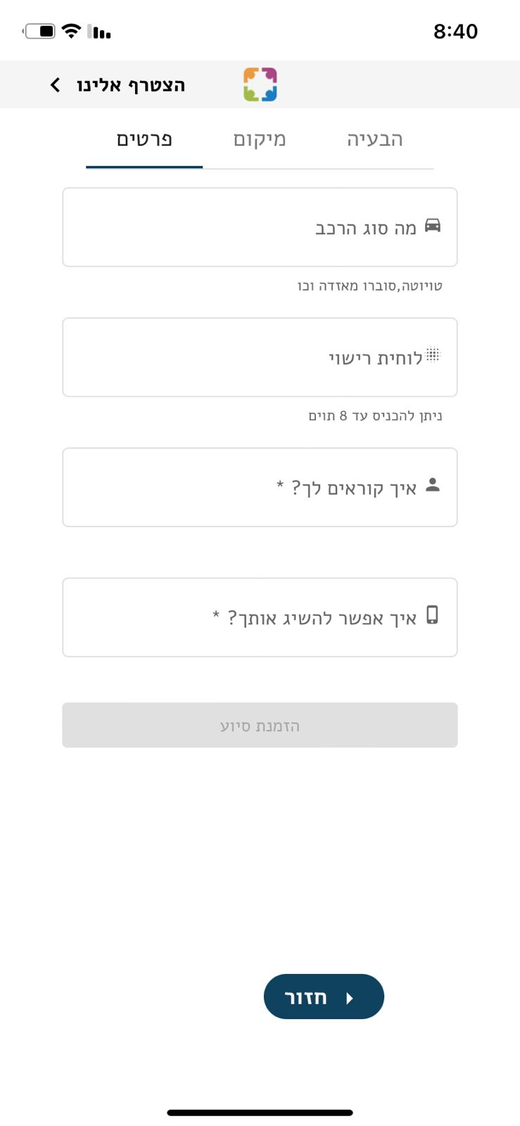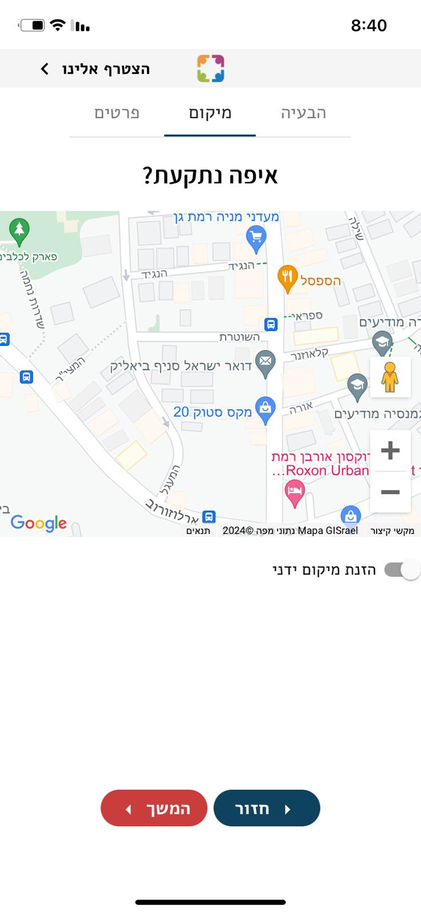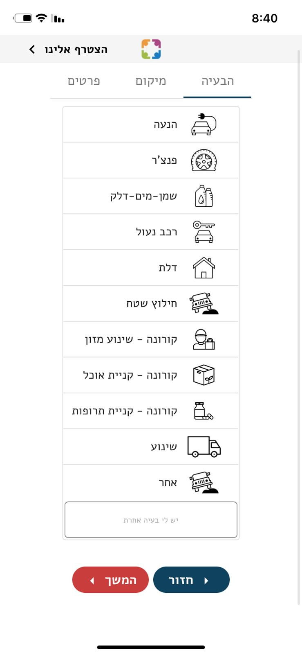

# **4. Expected Achievements**

## *4.1 Outcomes*:

Our envisioned project aims to revolutionize support for older individuals by introducing a comprehensive application that seamlessly connects them with compassionate volunteers, addressing the intricate challenges encountered in their daily lives. The primary issue revolves around the multifaceted nature of aging, encompassing physical limitations, cognitive changes, and the intricacies of managing healthcare needs. These challenges often lead to social isolation, compounding the overall impact on the well-being of older individuals. Beyond the physical realm, the lack of a robust support system exacerbates these difficulties, leaving many older individuals underserved and their unique needs unaddressed.

In response, our proposed application serves as a dynamic solution to bridge this gap and enhance the lives of older individuals. By allowing users to articulate their daily routines, challenges, and preferences, the application facilitates algorithmic matching with qualified volunteers. This personalized matching ensures that volunteers can provide targeted assistance, whether it's in grocery shopping, transportation, or companionship. The integration of features such as volunteer background checks, ratings, and reviews enhances the reliability and trustworthiness of the assistance provided, creating a secure environment for both parties involved. By harnessing technology to foster meaningful connections, the application aspires to mitigate the challenges of aging, elevate the quality of life for seniors, and instill a sense of community support in our interconnected world.

## *4.2 Unique Features*:

**Matching algorithm:**

The intricately designed matching algorithm, orchestrating the pairing of older individuals with compassionate volunteers, is a testament to thoughtful precision and care. This sophisticated framework delicately will be based on an algorithm that was already written by other students and considers geographical proximity. We will upgrade this algorithm to also consider volunteer ratings, and shared interests, all with the overarching goal of fostering harmonious and enriching connections.

Geographical proximity takes center stage, strategically placing volunteers within the same locality as the older individuals. This comprehensive algorithm aspires to create genuine, empathetic, and mutually fulfilling relationships between older individuals and volunteers, enriching the lives of both parties involved.

**The "ElderEase" application:**

The user-friendly interface of the application will allow older individuals to input details about their daily routines, challenges, and preferences, providing a personalized profile for optimal matching. The application will prioritize the development of a seamless user experience through a harmonious blend of frontend and backend technologies. It will be a combination of "Yedidim" and "Uber" application and will adopt the simpleness of those. By leveraging technology to create the meaningful connections between elder people to volunteers, the application strives to mitigate the challenges of aging, elevate the quality of life for older individuals, and foster a sense of community support in our interconnected world.

## *4.3 Criteria for Success*

The success of the application designed to connect older individuals with volunteers hinges on several key criteria:

**Efficient Matching Algorithm:** The algorithm's effectiveness in accurately pairing older individuals with volunteers based on geographical location, volunteer ratings, and shared interests is crucial. Success is measured by the algorithm's ability to create compatible and meaningful connections.

**User-Friendly Interface:** The application should provide a seamless and intuitive user experience for both older individuals and volunteers. Success is gauged by positive feedback on the interface's accessibility, ease of navigation, and the ability for users to input and update their profiles effortlessly.

**Effective Communication Channels:** The success of the application relies on providing secure and efficient communication channels between older individuals and volunteers. This involves real-time updates and a reliable means for users to interact, ensuring transparency and coordination.

**Community Engagement:** The application's success extends beyond practical support to fostering a sense of community. The platform should encourage users to share experiences, tips, and potentially engage in virtual events, creating a supportive and engaged community.

**User Satisfaction and Feedback:** Regular user feedback and satisfaction surveys will be essential indicators of success. Positive testimonials, improved well-being reported by older individuals, and continued volunteer engagement signify the application's positive impact.

By consistently meeting and exceeding these criteria, the application can be deemed successful in its mission to provide valuable support, foster connections, and enhance the overall well-being of older individuals.

# **5. The Process**

## *5.1 Research – The needs of older individuals*

Undertaking research on the needs of older individuals involves delving into multifaceted aspects to comprehensively understand and address their challenges. The investigation should explore not only the physical requirements, such as healthcare access, mobility assistance, and nutritional support but also delve into the intricacies of mental and emotional well-being. Examining the efficacy of existing support systems and identifying gaps in services is crucial. The research should also encompass the impact of technology on the lives of older individuals, exploring their proficiency, accessibility, and potential benefits in enhancing daily activities. Additionally, understanding social aspects, such as the importance of companionship, community engagement, and the influence of cultural factors on their well-being, is imperative. Examining the intersectionality of age-related needs, including gender, socioeconomic status, and cultural background, adds depth to the research. Finally, investigating the role of family dynamics and the availability of caregiving resources is essential for a comprehensive understanding of the diverse needs of older individuals, contributing to the development of tailored support systems and community initiatives.

Healthcare Access: Investigating the accessibility and effectiveness of healthcare services for older individuals, including the availability of geriatric specialists, proximity of medical facilities, and the utilization of telehealth options.

Research on the needs of older individuals can encompass various dimensions, including:

**Mobility and Transportation:** Examining the challenges older individuals face in terms of transportation, exploring solutions for convenient and accessible mobility options, and assessing the impact of transportation on their independence and social engagement.

**Nutritional Support:** Researching nutritional needs and dietary challenges among older individuals, with a focus on understanding factors affecting their food choices, addressing potential deficiencies, and ensuring access to balanced and age-appropriate meals.

**Mental Health and Emotional Well-being:** Exploring the mental health needs of older individuals, including the prevalence of loneliness, depression, and anxiety, and identifying interventions to promote emotional well-being, such as counseling services, support groups, or technology-based solutions.

**Technology Adoption:** Investigating the use and barriers of technology adoption among older individuals, with a focus on understanding their proficiency, preferences, and challenges in utilizing digital tools for communication, healthcare management, and social engagement.

**Companionship and Social Engagement:** Examining the significance of companionship and social interactions in the lives of older individuals, identifying factors that contribute to or hinder community engagement, and exploring interventions to reduce social isolation.

## *5.2 Methodology and Development Process*

In the development of our application aimed at facilitating support for older individuals, we have opted for an Agile methodology, which aligns seamlessly with the dynamic nature of our use case. Embracing an iterative approach, this methodology allows us to break down feature delivery into small, manageable components, providing maximum flexibility for adaptability to evolving requirements. Our development process unfolds through several key stages:

**User-Friendly Interface Design**: Commencing with the creation of an intuitive and user-friendly interface, our development kicks off by building the mobile application using a well-established platform suitable for older users.

**Functionalities and Features Implementation**: We proceed by incorporating essential tracking and movement functionalities within the application, ensuring a seamless user experience for both older individuals and volunteers.

**Data Storage and Retrieval Mechanism:** We integrate features allowing the secure storage and retrieval of essential data, enhancing the reliability and efficiency of the application's support services.

**Matching Algorithm Usage:** Leveraging advanced algorithms, we use the matching process to optimize compatibility between older individuals and volunteers based on geographical location, ratings, and shared interests.

**User Feedback Integration:** A key element of our iterative development is the incorporation of user feedback. We actively seek input from both older individuals and volunteers, making adjustments based on their experiences to enhance the application's effectiveness.

**Continuous Improvement:** The development process includes ongoing assessments and adaptations. We proactively address any challenges or inefficiencies identified during user testing, applying changes to ensure continuous improvement.

**Web-Based Interface Development**: As a final step, we create a web-based interface accessible to screening initiators. This interface will showcase the results, allowing for a comprehensive overview of the support activities and analysis.

Throughout the entire development cycle, each iteration concludes with an evaluation phase, where feedback from users is carefully considered. This feedback-driven approach ensures that the application evolves in line with the needs and preferences of older individuals and volunteers, ultimately delivering a comprehensive, user-centric solution to enhance the support system for seniors.

## *5.3 Development Process*

In our project development, we're adopting the Agile methodology, a well-established approach known for its emphasis on collaboration, adaptability, and continuous improvement. This method involves close collaboration with stakeholders throughout each phase of the project, from planning to execution and evaluation.  
  
To facilitate collaboration and ensure code integrity, we'll utilize tools like Visual Studio Code and Git. These tools will help us maintain well-organized codebases and streamline our development process. Additionally, Visual Studio Code's support for MongoDB will simplify data storage and retrieval tasks, further enhancing our efficiency and the quality of our product.  
  
Our development environment will primarily reside on a Google cloud instance, providing us with access to essential resources and tools for building and testing our product. GitLab will serve as our remote repository, enabling seamless code management and collaboration among team members. After completing each task or improvement, we'll push the latest code version to our Google cloud instance for user testing. This iterative approach will allow us to swiftly iterate on our product, ensuring it aligns with the needs and expectations of our users.

# **6. Product**

## *6.1 Our solution*

Our application aims to bridge the gap between adults in need of assistance and volunteers willing to lend a helping hand, with a special focus on seniors requiring aid in their daily lives. The platform facilitates seamless communication and coordination among three distinct user roles: volunteers, seniors, and managers, ensuring efficient assistance delivery.  
1) Volunteers:  
- Volunteers are individuals who offer their time and skills to assist seniors with various tasks, such as shopping or household chores.  
 - To join the platform, volunteers must fill out a directed online form, providing personal details and their location.   
 - Upon submission, volunteers undergo a screening process to ensure their suitability and reliability.  
- Once approved by the manager, volunteers gain access to the application and can view  
available tasks in their area.

2. Seniors:  
- Seniors are individuals who require assistance with daily tasks and chores due to age-related limitations.  
- Seniors can request help either by phone or directly through the application.  
- Their requests are verified by an administrator to ensure authenticity and urgency.  
 - After verification, the administrator uploads the request to the application, specifying the relevant location.  
3. Managers/Administrators:  
- Managers oversee the operations of the application and are responsible for vetting volunteers and verifying assistance requests.  
- They add approved volunteers to the application after the screening process.  
 - Managers verify and upload assistance requests from seniors, ensuring proper allocation and coordination of tasks.  
Workflow:  
1. Volunteer Registration: Volunteers fill out an online form, providing personal details and location information.  
2. Screening Process: Volunteers undergo a screening day to assess their suitability and reliability.  
3. Approval by Manager: Approved volunteers are added to the application by the manager.  
4. Seniors Request Assistance: Seniors request assistance through the application or by phone.  
5. Verification by Administrator: Administrators verify the requests for authenticity and urgency.  
6. Upload to Application: Verified requests are uploaded to the application, specifying the location of the senior in need.  
7. Task Allocation: Volunteers with the necessary skills and proximity to the senior's location are notified of the task and provide assistance accordingly.

By streamlining the process of connecting volunteers with seniors in need, our application aims to foster a supportive community where individuals can receive the help they require to maintain their independence and quality of life.We're embarking on an ambitious project aimed at revolutionizing the way volunteers connect with elderly individuals in need of daily assistance. Through innovative features such as a tracking system and a matching algorithm, we're committed to ensuring that volunteers are readily available and equipped to fulfill their responsibilities promptly. This initiative not only benefits the elderly individuals receiving assistance but also empowers managers to monitor task progress and evaluate volunteer performance effectively.

## *6.2 Requirements*

**Functional:**

|  |  |
| --- | --- |
| **1** | The application shall allow volunteers to create profiles |
| **2** | The application shall allow elderly individuals to create profiles |
| **3** | The application shall let the users add relevant information to their profile |
| **4** | The application shall let users sign into their account |
| **5** | The system will store data in a database |
| **6** | The application shall present a list of activities for which the elder can choose to ask help. |
| **7** | The application shall allow elderly users to rate and provide reviews for volunteers, providing feedback on the quality of assistance and companionship. |
| **8** | The application shall utilize location services to identify and connect users who are in close proximity for easier coordination. |

**Non-functional:**

|  |  |
| --- | --- |
| **1** | The system shall be designed to handle a growing number of users and data as the user base expands. |
| **2** | The application shall implement robust security measures to protect user data and ensure privacy during communication. |
| **3** | The system shall be reliable, minimizing downtime and ensuring consistent availability for users. |
| **4** | The application shall be compatible with a variety of devices (smartphones, tablets, etc.) and operating systems to maximize accessibility. |
| **5** | The application shall include accessibility features, such as adjustable font sizes and compatibility with screen readers, to accommodate users with different needs. |
| **6** | The system shall have regular data backup procedures and a reliable recovery mechanism to prevent data loss. |

## *6.3 System functionality*

Our application boasts an array of intuitive and robust features tailored to facilitate seamless coordination between volunteers, seniors, and managers, ensuring efficient assistance for those in need. From real-time task tracking and volunteer availability to comprehensive reporting and performance metrics, our system offers valuable insights for optimizing the assistance process. Moreover, our platform streamlines the process of matching volunteers with seniors, enabling the submission of tasks, handling complaints and ratings, and generating mission reports.

The application's management protocol ensures a structured onboarding process for volunteers, including targeted form submissions and screening days overseen by managers. Once approved, volunteers are seamlessly integrated into the system. Seniors seeking assistance can place orders via phone or the application, triggering manager verification before the request is fulfilled.

With these features and more, our application is primed to meet the needs of both volunteers and seniors, enhancing the overall experience of assistance provision. For a detailed overview of functionalities, please refer to Tables 6.3.1 – 6.3.3.  
  
Table 6.3.1- Manager functionalities:

|  |  |
| --- | --- |
| Functionality | Description |
| Volunteer Registration | Manages volunteer applications, screenings, and adds approved volunteers to the app. |
| Volunteer-Manager Communication | Enables direct communication between managers and volunteers to discuss tasks and schedules. |
| Elderly Registration | Manages registration of elderly individuals needing assistance through TLS or app calls. |
| Request Verification | Verifies and approves requests for assistance from elderly individuals. |
| Volunteer Assignment | Matches volunteers with elderly based on needs, volunteer skills and location. |
| Schedule Management | Manages schedules and availability of volunteers for assisting elderly If necessary. |
| Notification System | Sends notifications to managers, volunteers, and the elderly about updates, schedules, and urgent needs. |

Table 6.3.2- Volunteer functionalities:

|  |  |
| --- | --- |
| Functionality | Description |
| Task Dashboard | Displays available tasks and allows volunteers to accept tasks they can perform (e.g., shopping, handywork). |
| Schedule Availability | Volunteers update their availability for tasks. |
| Direct Messaging | Allows volunteers to communicate directly with managers and elderly for task details and updates. |
| Task Completion Submission | Volunteers submit confirmation and details of task completion. |
| Elderly Feedback | Enables volunteers to receive feedback from the elderly they assist. |

Table 6.3.3- Elderly functionalities:

|  |  |
| --- | --- |
| Functionality | Description |
| Request Assistance | Allows elderly to request assistance via the app or TLS for daily tasks. |
| Rate Volunteers | Enables elderly to rate volunteers after task completion. |
| View Volunteer Profiles | Elderly can view profiles of linked volunteers, including past feedback and skills. |
| Notifications | Receives notifications about volunteer visits, schedule changes, and other updates. |
| Direct Messaging | Enables direct communication with volunteers and managers for immediate needs or updates. |

## *6.4 Technology choices:*

### *Icon Description automatically generated6.4.1* *Back-end NODEJS*

An open-source, cross-platform runtime environment for JavaScript is  
Node.js10. The core of Google Chrome, the V8 JavaScript engine, is run by Node.js outside of the browser.  
Without starting a new thread for each request, a Node.js application operates in a single process. Blocking behavior in Node.js libraries is the exception rather than the rule since libraries in Node.js are typically created using non-blocking paradigms and because Node.js includes a set of asynchronous I/O primitives in its standard library that prevent JavaScript code from blocking.  
Instead of pausing the thread and spending CPU time waiting for an I/O action, such as reading from the network or accessing a database or disk, Node.js will continue its work once the response has been received.  
This eliminates the complexity of managing thread concurrency, which might be a substantial source of errors, and allows Node.js to manage thousands of concurrent connections with a single server.  
Node.js has a distinct benefit since it allows the millions of frontend developers who write JavaScript for the browser to create both server-side and client-side code without having to  
switch to a new language.NODEJS advantages:   
1) High-performance for Real-time Applications.  
2) Easy Scalability for Modern Applications.  
3) Cost-effective with Fullstack JS.  
4) Community Support to Simplify Development.  
5) Easy to Learn and Quick to Adapt.  
6) Helps in building Cross-functional Teams.  
7) Improves App Response Time and Boosts Performance.  
8) Reduces Time-to-Market of your applications.  
9) Extensibility to Meet Customized Requirements.  
10) Reduces Loading Time by Quick Caching.  
11) Helps in Building Cross-Platform Applications.

NODEJS disadvantages:  
1) Reduces performance when handling Heavy Computing Tasks.  
2) Node.js invites a lot of code changes due to Unstable API.  
3) Node.js Asynchronous Programming Model makes it difficult to maintain code.  
4) Choose Wisely – Lack of Library Support can Endanger your Code.  
5) High demand with a few Experienced Node.js Developers.

### *6.4.2 Back-end MONGODB*

  
MongoDB is a cross-platform document-oriented database application that is open source. MongoDB, a NoSQL database application, employs documents that resemble JSON and may or may not include schemas. The Server-Side Public License (SSPL), which is used by MongoDB Inc. to develop the database, is viewed as non-free by several distributions.

MONGODB advantages:  
1) Schema less − MongoDB is a document database in which one collection holds different documents. Number of fields, content and size of the document can differ from one document to another.  
2) Structure of a single object is clear.  
3) No complex joins.  
4) Deep query-ability. MongoDB supports dynamic queries on documents using a document-based query language that's nearly as powerful as SQL.  
  
MONGODB disadvantages:  
1) Resource-intensive operations.  
2) Limited SQL support.  
3) High memory consumption.  
4) Backup and recovery complexity.  
5) Disparity in features between Community and Enterprise editions.

### *6.4.3 Front-end REACT-NATIVE*

With the help of the open-source JavaScript framework React Native, developers can create apps for different operating systems, including iOS, Android, and the web. It is based on React and brings all of its splendor to the creation of mobile apps.  
While leveraging native-OS views, React Native compiles the app's user interface using JavaScript. It permits code implementation in OS-native languages for more complicated functionality (Swift and Objective-C for iOS, and Java and Kotlin for Android).  
  
REACT-NATIVE advantages:  
1) Cross-Platform Development: Build apps for both iOS and Android with one codebase.  
2) Code Reusability: Use the same code across platforms, reducing development time.  
3) Fast Development: Develop quickly with features like hot reloading for real-time updates.  
4) Large Community: Benefit from a vast community and ecosystem for support and resources.  
5) Performance: Achieve near-native performance with optimized JavaScript execution.  
6) Live Updates: Push updates directly to users' devices without app store approval.  
7) Access to Native APIs: Access device features seamlessly using JavaScript.  
  
REACT-NATIVE disadvantages:  
1) Limited Native Functionality: Some advanced native features may require custom integration.  
2) Performance Bottlenecks: Complex tasks may experience performance issues compared to fully native apps.  
3) Platform Fragmentation: Different iOS and Android versions may lead to compatibility challenges.  
4) Learning Curve: Newcomers may find React Native's concepts and tools challenging initially.  
5) Native Modules and Dependencies: Integrating custom modules may introduce complexities.  
6) Debugging Complexity: Debugging React Native apps can be more complex than traditional web or native apps.  
  
EXPO GO   
Expo Go is a mobile app that allows developers to quickly and easily test and share their React Native projects without needing to build and install standalone apps on physical devices. It serves as a companion app for Expo, a set of tools and services for building React Native apps. With Expo Go, developers can scan a QR code generated by their Expo project to load and run their app instantly on their iOS or Android device. This eliminates the need for complex build configurations and speeds up the development and testing process. Expo Go also provides access to device features such as camera, location, and sensors, allowing developers to test their app's functionality in a real-world environment. Additionally, Expo Go allows developers to share their projects with others for testing and feedback by simply sending them a link to open the project in the Expo Go app. Overall, Expo Go simplifies the development, testing, and sharing of React Native apps, making it a valuable tool for developers.

### *6.4.4 Visual studio code framework*

Visual Studio Code is a source-code editor made by Microsoft with the Electron Framework, for Windows, Linux and macOS. Features include support for debugging, syntax highlighting, intelligent code completion, snippets, code refactoring, and embedded Git.   
  
Features:   
Visual Studio Code is a source-code editor that can be used with a variety of programming languages, including C#, Java, JavaScript, Go, Node.js, Python, C++, C, Rust, and Fortran. It is based on the Electron framework, which is used to develop Node.js web applications that run on the Blink layout engine. Visual Studio Code employs the same editor component (codenamed "Monaco") used in Azure DevOps (formerly called Visual Studio Online and Visual Studio Team Services)  
Out of the box, Visual Studio Code includes basic support for most common programming languages. This basic support includes syntax highlighting, bracket matching, code folding, and configurable snippets. Visual Studio Code also ships with IntelliSense for JavaScript, TypeScript, JSON, CSS, and HTML, as well as debugging support for Node.js. Support for additional languages can be provided by freely available extensions on the VS Code Marketplace.

## *6.5 Project structure*

In today's dynamic technological landscape, the demands and expectations of users worldwide are continually evolving. Users now expect applications that not only respond promptly to their inputs but also offer rich, interactive experiences that engage and captivate them. To meet these ever-rising standards, developers are tasked with harnessing the power of cutting-edge technologies and frameworks.  
This is where technology stacks come into play. These stacks are meticulously crafted combinations of tools, frameworks, and libraries that developers leverage to build robust and efficient software solutions. By carefully selecting and integrating components within a technology stack, developers can streamline development processes, optimize performance, and deliver exceptional user experiences.  
  
Among the plethora of technology stacks available, the MERN stack stands out as a popular choice for building modern web applications. MERN is an acronym representing four key technologies: MongoDB, Express.js, React.js, and Node.js. Each component of the MERN stack plays a vital role in the development process:  
  
**MongoDB:** A flexible and scalable NoSQL database, MongoDB stores data in a JSON-like format, making it well-suited for handling diverse and evolving data structures.  
**Express.js**: A minimalist web framework for Node.js, Express.js simplifies the process of building robust and scalable web applications by providing a range of features and utilities for handling HTTP requests, routing, and middleware.  
**React.js:** A powerful JavaScript library developed by Facebook, React.js enables developers to build interactive user interfaces by composing reusable UI components. Its component-based architecture and virtual DOM offer efficiency and flexibility in rendering complex UIs.  
**Node.js:** A server-side JavaScript runtime environment, Node.js allows developers to build scalable and high-performance server applications. Its event-driven architecture and non-blocking I/O model make it ideal for building real-time and data-intensive applications.  
  
When combined, these technologies empower developers to create a comprehensive three-tier architecture, encompassing the frontend, backend, and database layers, all using JavaScript and JSON. This unified approach not only streamlines development but also fosters consistency and coherence across the entire application stack.  
  
The MERN stack provides developers with a versatile and efficient toolkit for building a wide range of applications, from simple web interfaces to complex, data-driven platforms. By leveraging the capabilities of each component within the MERN stack, developers can create applications that are not only powerful and scalable but also capable of delivering seamless and immersive user experiences.

* 1. *Algorithms*:

1) User Authentication Algorithm: This algorithm ensures secure authentication of users (volunteers, seniors, and managers) before granting access to the application's features and functionalities.  
2) Matching Algorithm: This algorithm matches volunteers with seniors based on various criteria such as location, availability, and skills. It ensures efficient pairing to fulfill seniors' needs effectively.  
3) Task Assignment Algorithm: This algorithm assigns tasks requested by seniors to available volunteers. It considers factors like volunteer availability, proximity to the senior, and task complexity to optimize task assignments.  
4) Screening Algorithm: This algorithm evaluates volunteer applicants based on predefined criteria during the screening process. It ensures that only qualified and reliable volunteers are admitted to the platform.  
5) Verification Algorithm: This algorithm verifies requests for assistance from seniors to ensure their authenticity and validity. It may involve contacting seniors or cross-referencing information provided in the request.  
6) Notification Algorithm: This algorithm sends notifications to volunteers, seniors, and managers regarding task assignments, updates, and reminders. It ensures timely communication and coordination among all parties involved.  
7) Feedback Algorithm: This algorithm collects feedback from seniors regarding the assistance provided by volunteers. It helps assess volunteer performance and improve service quality over time.  
8) Rating and Review Algorithm: This algorithm allows seniors to rate and review volunteers based on their satisfaction with the assistance received. It helps maintain accountability and transparency within the community.  
9) Scheduling Algorithm: This algorithm assists in scheduling screening days for volunteers and coordinating task assignments based on availability and priority.  
10) Data Encryption Algorithm: This algorithm ensures the security and privacy of sensitive user data, such as personal information and communication logs, by encrypting them before storage or transmission.

* 1. *Diagrams*:

### *6.7.1 use case diagram*

* + 1. *A diagram of a computer system

       Description automatically generatedActivity diagram*

## *6.8 Tests*

*6.8.1 Login Tests:*

|  |  |  |  |  |
| --- | --- | --- | --- | --- |
| Test Name | Description | Expected Results | Actual Results | Comments |
| Test valid volunteer login | Volunteer logs in with valid credentials. | Volunteer is logged in successfully; directed to appropriate dashboard. | Successfully logged in | Homepage loaded with volunteer dashboard. |
| Test invalid volunteer login | Volunteer logs in with invalid credentials. | Error message displayed; login fails. | Failed to log in | Error: Incorrect username or password. |
| Test valid manager login | Manager logs in with valid credentials. | Manager is logged in successfully; directed to manager dashboard. | Successfully logged in | Homepage loaded with manager dashboard. |
| Test invalid manager login | Manager logs in with invalid credentials. | Error message displayed; login fails. | Failed to log in | Error: Incorrect username or password. |
| Test login without username | User attempts to log in without entering a username. | Error message displayed; login fails. | Failed to log in | Error: Username required. |
| Test login without password | User attempts to log in without entering a password. | Error message displayed; login fails. | Failed to log in | Error: Password required. |
| Test login with expired credentials | User attempts to log in with credentials that have expired (if applicable). | User is prompted to update password or renew credentials. | Prompt for renewal | Prompt to renew or change password. |

### *6.8.2 Volunteer & Pre-Volunteer Tests*

|  |  |  |  |  |
| --- | --- | --- | --- | --- |
| Test Name | Description | Expected Results | Actual Results | Comments |
| Pre-Volunteer Registration | Pre-Volunteer completes registration form with valid details. | Registration submitted and awaiting manager approval. | Successfully submitted | Awaiting manager review. |
| Incomplete Pre-Volunteer Registration | Pre-Volunteer submits incomplete registration form. | Error message shown; registration not submitted. | Submission failed | Missing fields indicated. |
| Test update volunteer skills | Volunteer updates their skills profile in the app. | Skills profile updated successfully. | Successfully updated | Updated skills reflected in the volunteer profile. |
| Test incomplete task submission | Volunteer tries to submit a task completion form without all required fields filled. | Submission fails; error message displayed. | Failed to submit | Error: "All fields must be filled out." |
| Test complete task submission | Volunteer submits a completed task form with all required fields filled. | Task marked as completed; notification sent to manager and senior. | Successfully submitted | Task status updated in the system. |
| Test volunteer availability update | Volunteer updates their availability status in the app. | Availability status updated successfully. | Successfully updated | Availability reflected in volunteer's profile. |
| Test logout functionality | Volunteer logs out of the app. | User is logged out successfully; session ended securely. | Successfully logged out | User redirected to login page. |
| Test feedback submission after task | Volunteer submits feedback after completing a task. | Feedback submitted successfully; available for review by managers. | Successfully submitted | Feedback recorded in the system. |

### *6.8.3 elderly Tests*

|  |  |  |  |  |
| --- | --- | --- | --- | --- |
| Test Name | Description | Expected Results | Actual Results | Comments |
| Request complete Assistance | elderly submit a request for assistance through the app. | Request successfully submitted and visible to managers. | Successfully submitted | Request queued for manager approval. |
| Request incomplete Assistance | Elderly submits a request with missing details. | Error message shown; request not submitted. | Submission failed | Missing details indicated. |
| Update Request | Elderly updates an existing assistance request. | Request updated successfully. | Successfully updated | Request details modified. |
| Cancel Request | Elderly cancels a previously submitted request. | Request successfully canceled. | Successfully canceled | Request removed from system. |

### *6.8.4 Manager Tests*

|  |  |  |  |  |
| --- | --- | --- | --- | --- |
| Test Name | Description | Expected Results | Actual Results | Comments |
| Approve Volunteer | Manager reviews and approves a volunteer registration. | Volunteer approved and notified. | Successfully approved | Volunteer can now accept tasks. |
| Reject Volunteer | Manager reviews and rejects a volunteer registration. | Volunteer rejected and notified. | Successfully rejected | Rejection reasons provided to volunteer. |
| Verify elderly Request | Manager verifies details of a elderly request for assistance. | Request verified and posted for volunteers. | Successfully verified | Request available for volunteers. |
| Assign Task to Volunteer | Manager manually assigns a task to a specific volunteer. | Task assigned and volunteer notified. | Successfully assigned | Volunteer tasked with assistance. |

# **7. GUI**

## *7.1 Elder's screens:*

Elders can open a help request. After that they will have few options for volunteers they can pick, assigned by the manager. The elders will pick the volunteer they want and after all will be able to leave feedback in the volunteer's profile.

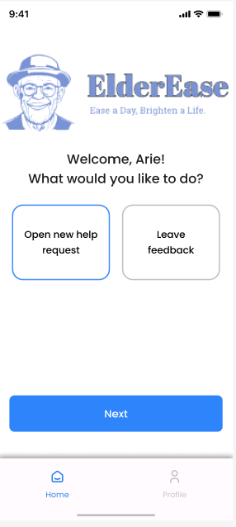

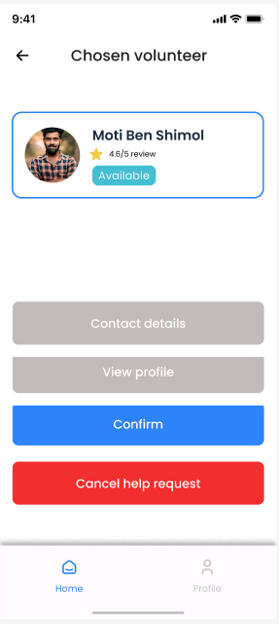

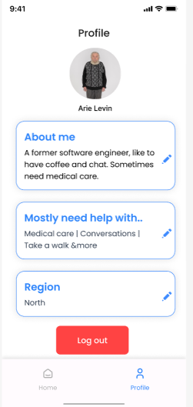

*7.2 Manager's Screens:*

Managers will be able to add new volunteers, assign help requests to volunteers, close help requests and leave feedback about the volunteers.

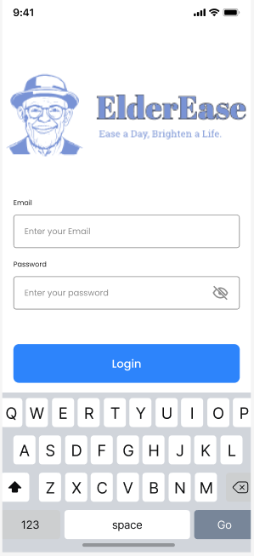

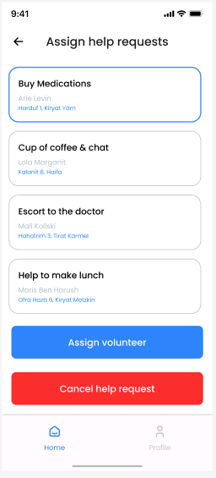

*7.3 Volunteer's Screens:*

Volunteers will be able to choose a help request among a list of help requests that are assigned to them. When they choose one, an update is sent to the elder and he has to approve it before the volunteer gets on his way to help him. After the approval – the volunteer will get the full details, including the elder's phone number for contact.

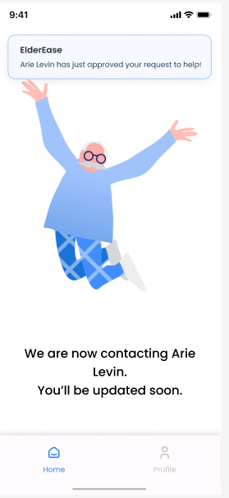

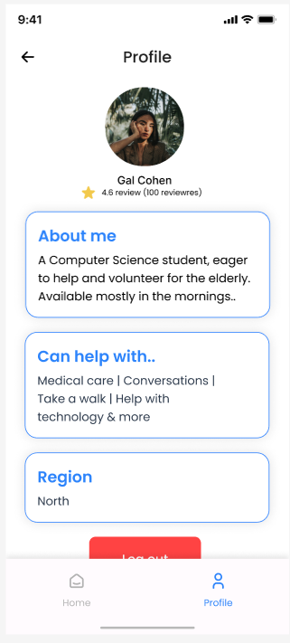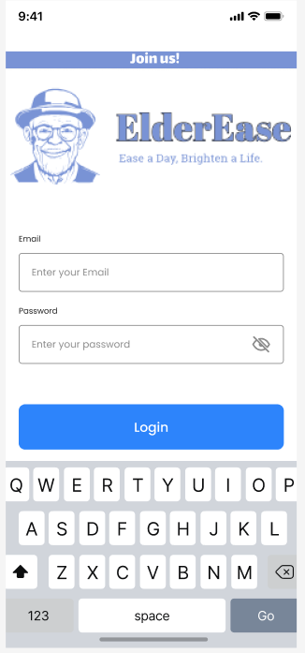

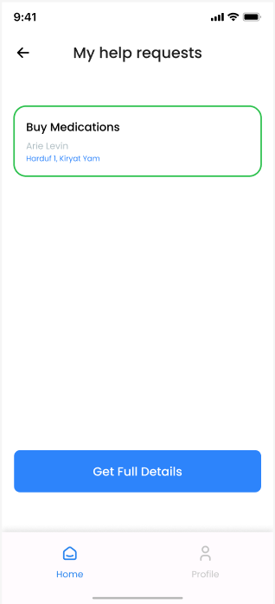

**8. References**

1. “Re Holt-Lunstad, J., Smith, T. B., & Layton, J. B. (2010). Social relationships and mortality risk: A meta-analytic review. PLOS Medicine, 7(7), e1000316.
2. Hawkley, L. C., & Cacioppo, J. T. (2010). Loneliness matters: A theoretical and empirical review of consequences and mechanisms. Annals of Behavioral Medicine, 40(2), 218-227.
3. Buffel, T., & Handler, S. (2014). Ageing in urban environments: Developing ‘age-friendly’ cities. Critical Social Policy, 34(1), 34-58.
4. Morrow-Howell, N., Galucia, N., & Swinford, E. (2020). Recovering from the COVID-19 pandemic: A focus on older adults. Journal of Aging & Social Policy, 32(4-5), 526-535.
5. Warburton, J., Lui, C. W., & Kagan, C. (2013). How older people enact care involvement during transitions from hospital to home: A mixed methods study. International Journal of Nursing Studies, 50(11), 1608-1618.
6. Gorges, R. J., Konetzka, R. T., & Werner, R. M. (2015). End-of-life care in nursing homes: Importance of CNA staff communication. Journal of the American Geriatrics Society, 63(7), 1242-1247.
7. Li, Y., Ferraro, K. F., & Volunteering, Social Integration, and Life Satisfaction: An Investigation of Voluntary Associations' Subjective Well-Being Production Functions. Social Science Research, 78, 131-144.
8. Musick, M. A., & Wilson, J. (2008). Volunteers: A social profile. Indiana University Press.
9. Cohen-Mansfield, J., Dakheel-Ali, M., & Jensen, B. (2015). Volunteer Visiting Program for Older Adults: Participant Outcomes. Journal of Applied Gerontology, 34(1), 3-19.
10. Node.js — Introduction to Node.js. (n.d.). <https://nodejs.dev/en/learn/>
11. GeeksforGeeks. (2023, December 1). MongoDB Advantages Disadvantages. GeeksforGeeks. https://www.geeksforgeeks.org/mongodb-advantages-disadvantages/